Assignment No 3



Spring 2025

**CSE-408 Digital Image Processing**

Submitted by: MUHAMMAD SADEEQ

Registration No.: 21PWCSE2028

Section: C

“On my honor, as a student of the University of Engineering and Technology, I have neither given nor received unauthorized assistance on this academic work”

Submitted to:

Engr. Mehran Ahmad

(20 June 2025)

Department of Computer systems engineering

University of Engineering and Technology, Peshawar

**Activity 1**

**Code:**

% Clear environment

clc; clear; close all;

% Load grayscale image

img = imread('cameraman.tif');

img = im2double(img);

[M, N] = size(img);

% Fourier Transform

F = fft2(img);

F_shifted = fftshift(F);

% Set cutoff frequency

D0 = 50;

% Create meshgrid

u = 0:(M-1);

v = 0:(N-1);

u = u - floor(M/2);

v = v - floor(N/2);

[U, V] = meshgrid(v, u);

D = sqrt(U.^2 + V.^2);

% Ideal Lowpass Filter

H_ideal = double(D <= D0);

% Butterworth Lowpass Filter (order = 2)

n = 2;

H_butter = 1 ./ (1 + (D ./ D0).^(2 * n));

% Gaussian Lowpass Filter

H_gauss = exp(-(D.^2) ./ (2 * D0^2));

% Apply filters in frequency domain

G_ideal = F_shifted .* H_ideal;

G_butter = F_shifted .* H_butter;

G_gauss = F_shifted .* H_gauss;

% Inverse FFT

img_ideal = real(ifft2(ifftshift(G_ideal)));

img_butter = real(ifft2(ifftshift(G_butter)));

img_gauss = real(ifft2(ifftshift(G_gauss)));

% Display results

figure;

subplot(1,2,1), imshow(img, []), title('Original Image');

subplot(1,2,2), imshow(log(1+abs(F_shifted)), []), title('Original Spectrum');

figure;

subplot(1,2,1), imshow(img_ideal, []), title('ILPF Output');

subplot(1,2,2), imshow(log(1+abs(G_ideal)), []), title('ILPF Spectrum');

figure;

subplot(1,2,1), imshow(img_butter, []), title('BLPF (n=2) Output');

subplot(1,2,2), imshow(log(1+abs(G_butter)), []), title('BLPF Spectrum');

figure;

subplot(1,2,1), imshow(img_gauss, []), title('GLPF Output');

subplot(1,2,2), imshow(log(1+abs(G_gauss)), []), title('GLPF Spectrum');

**Output:**

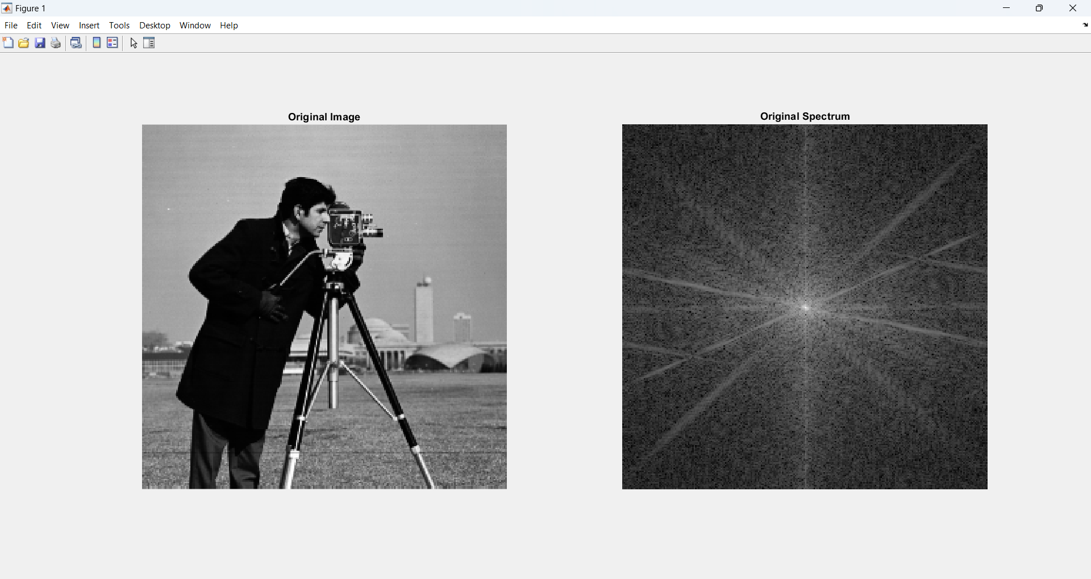

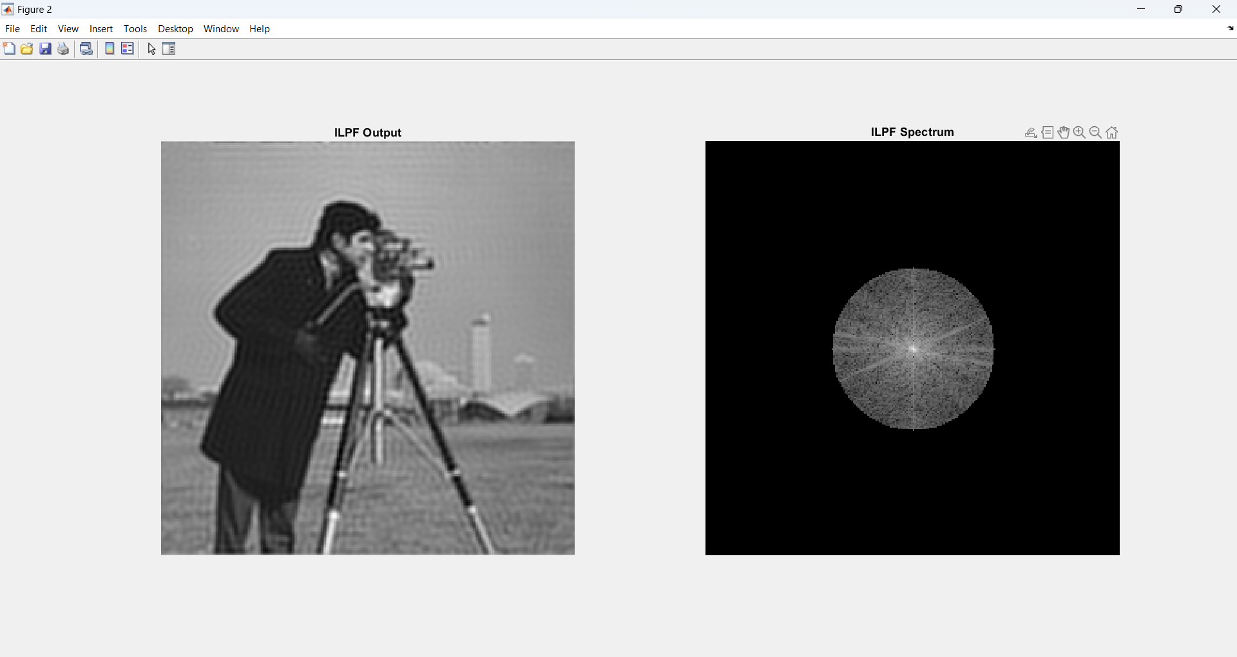

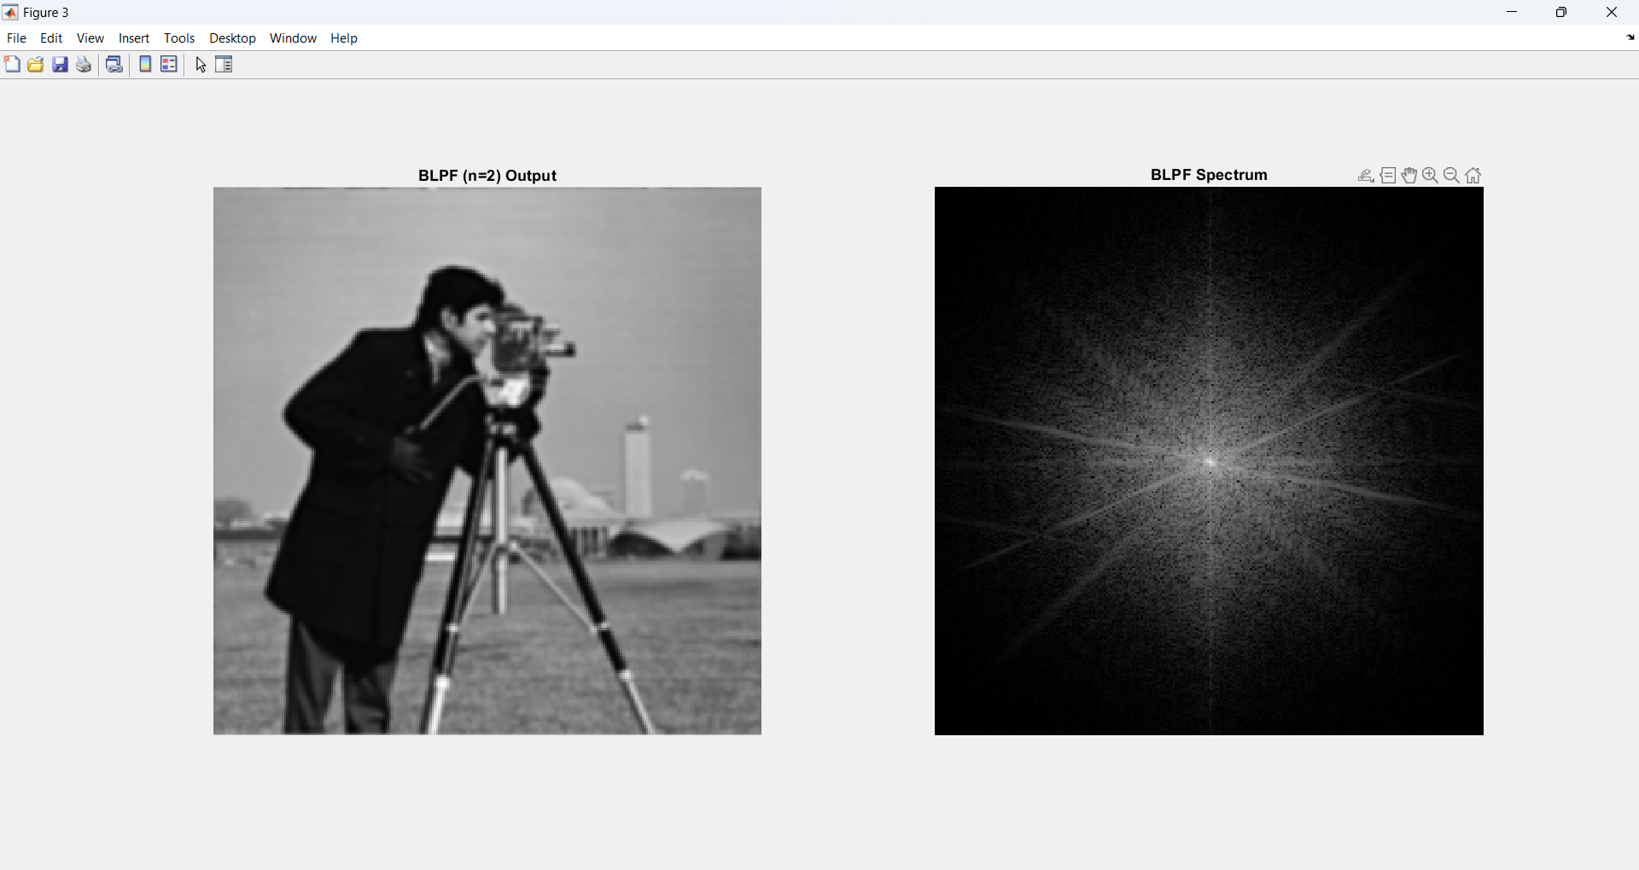

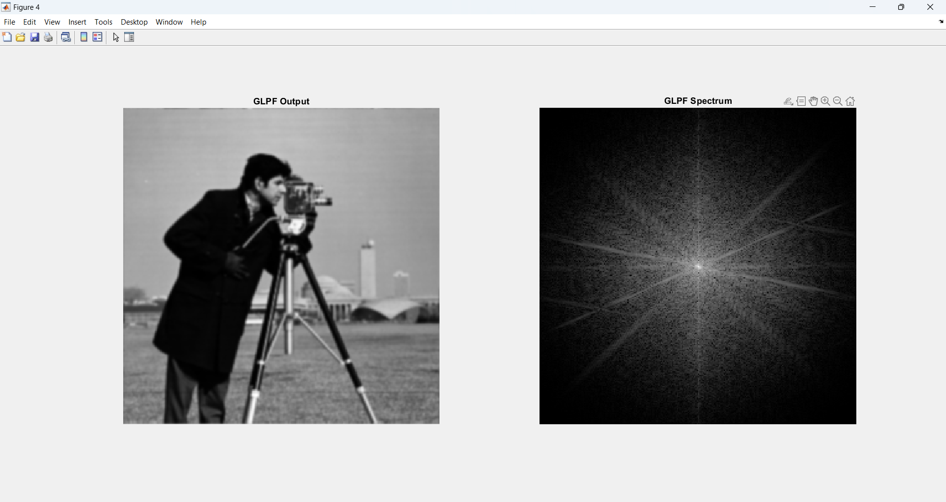

## ****Analysis****

Three frequency domain lowpass filters were applied to a grayscale image:

* **Ideal Lowpass Filter (ILPF):** Strong smoothing but introduces ringing artifacts due to abrupt frequency cutoff. Poor at preserving edges.
* **Butterworth Lowpass Filter (BLPF):** Offers a good balance between noise reduction and edge preservation with fewer artifacts than ILPF.
* **Gaussian Lowpass Filter (GLPF):** Smoothest filtering with excellent noise reduction and minimal artifacts. Best at preserving image details.

## ****Conclusion****

The **Gaussian Lowpass Filter** performs best overall, effectively reducing noise while preserving edges and avoiding artifacts. The **Butterworth Filter** is a good compromise, while the **Ideal Filter** is least effective due to noticeable visual distortions.